Face Recognition

*by*

Aryan Gunjal

Dhyey Vyas

Jignashu Vaghela

**Submission date:** 13-Apr-2023 11:41AM (UTC+0530)

**Submission ID:** 2063209971

**File name:** report_sgp.pdf (135.49K)

**Word count:** 1559

**Character count:** 8512

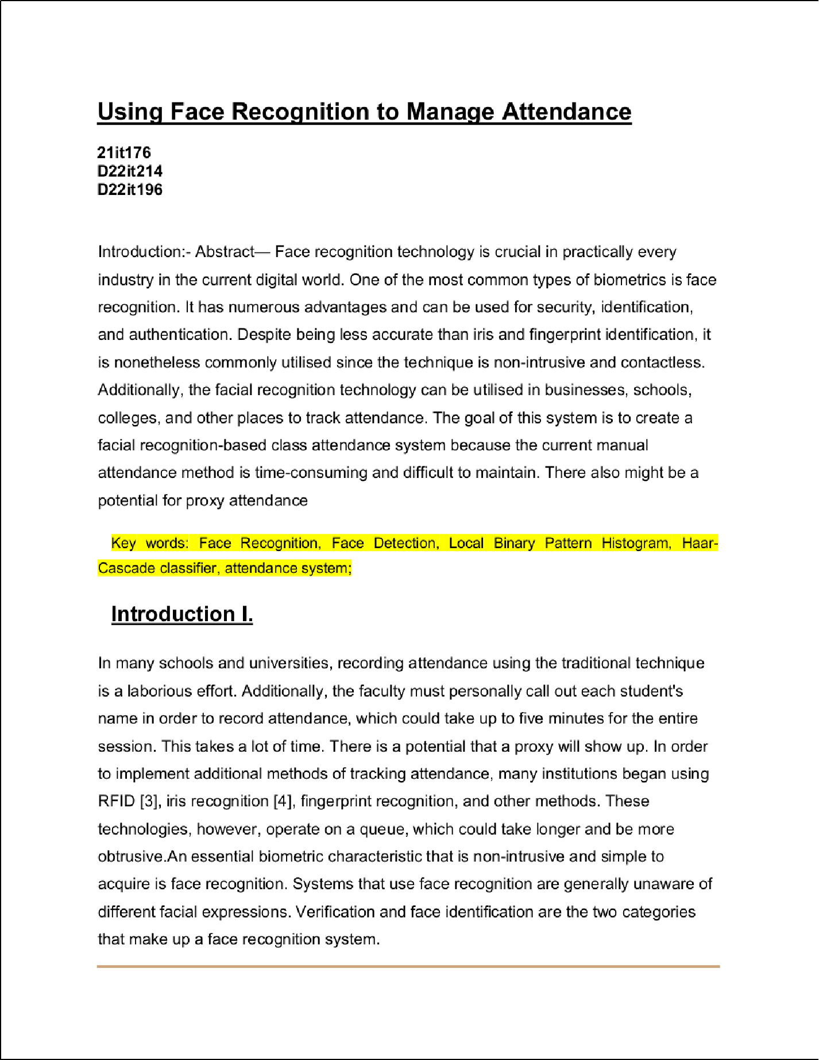

Wrong Article

2

Article Error 2

1

2

2

2

3

2

Frag.

1

2

1

2

1

1

1

2

Art2icle Error Article Error

Missing "," Prep.

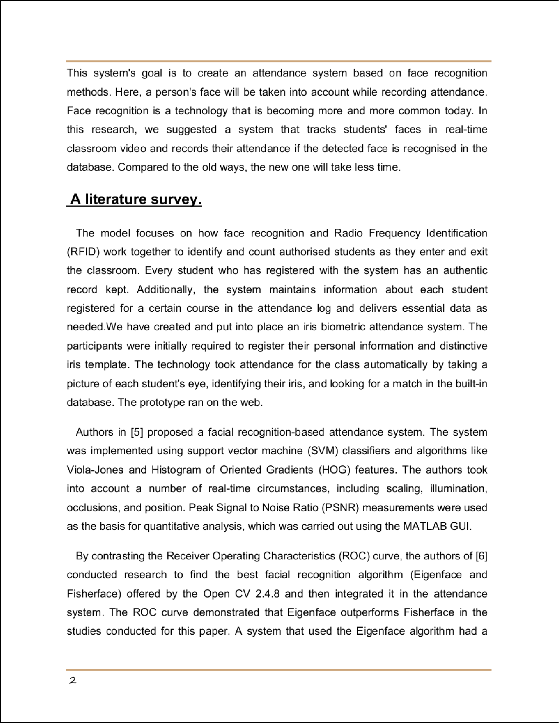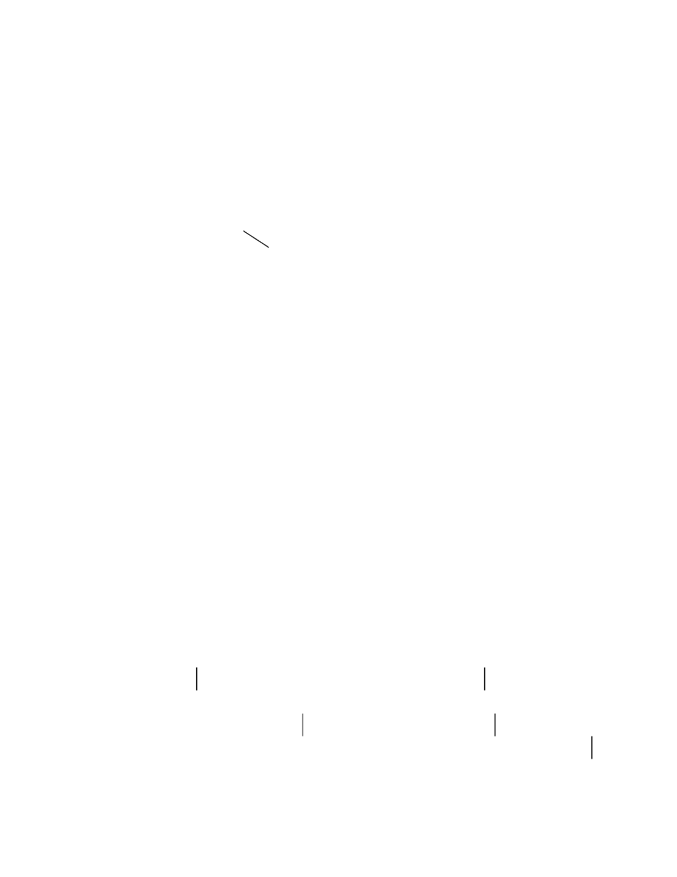

2

Article Error

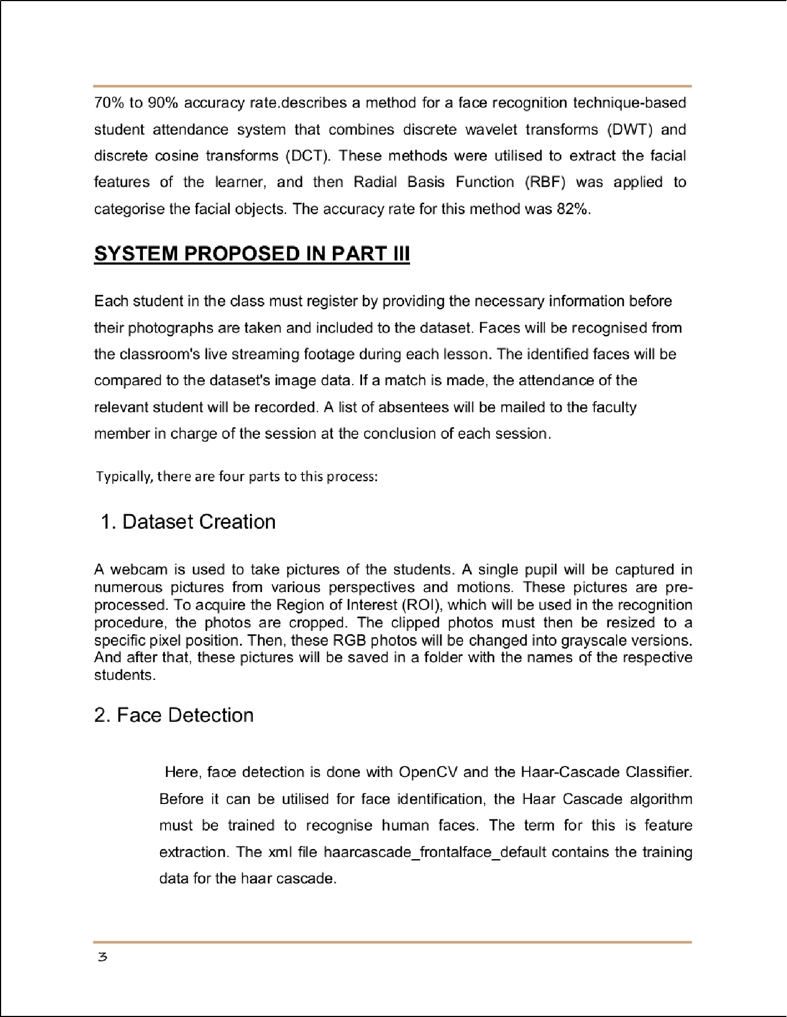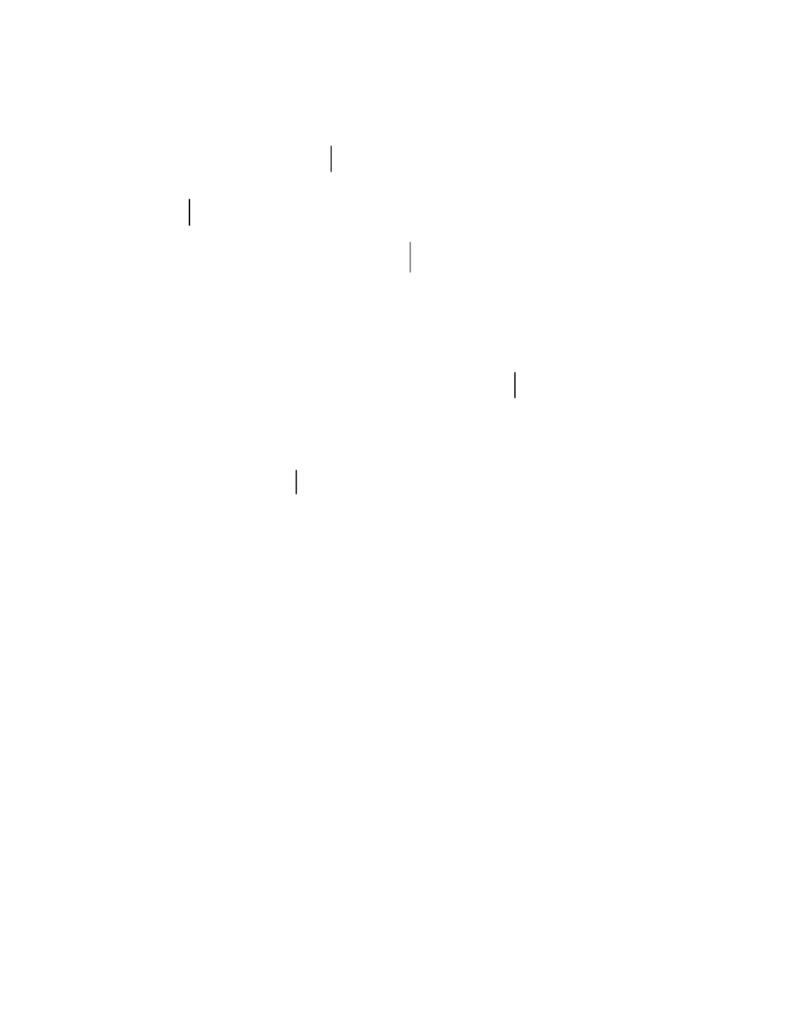

2

Sentence Cap.

Article Error

Missing ","

3

Article Error

Prep.

4

5

4

1

1

Sp.

1

Sp. Sp. Sp.

Sp.

SPp/.V

Sp.

SPp/.V

Article Error

1

1 6

1

1

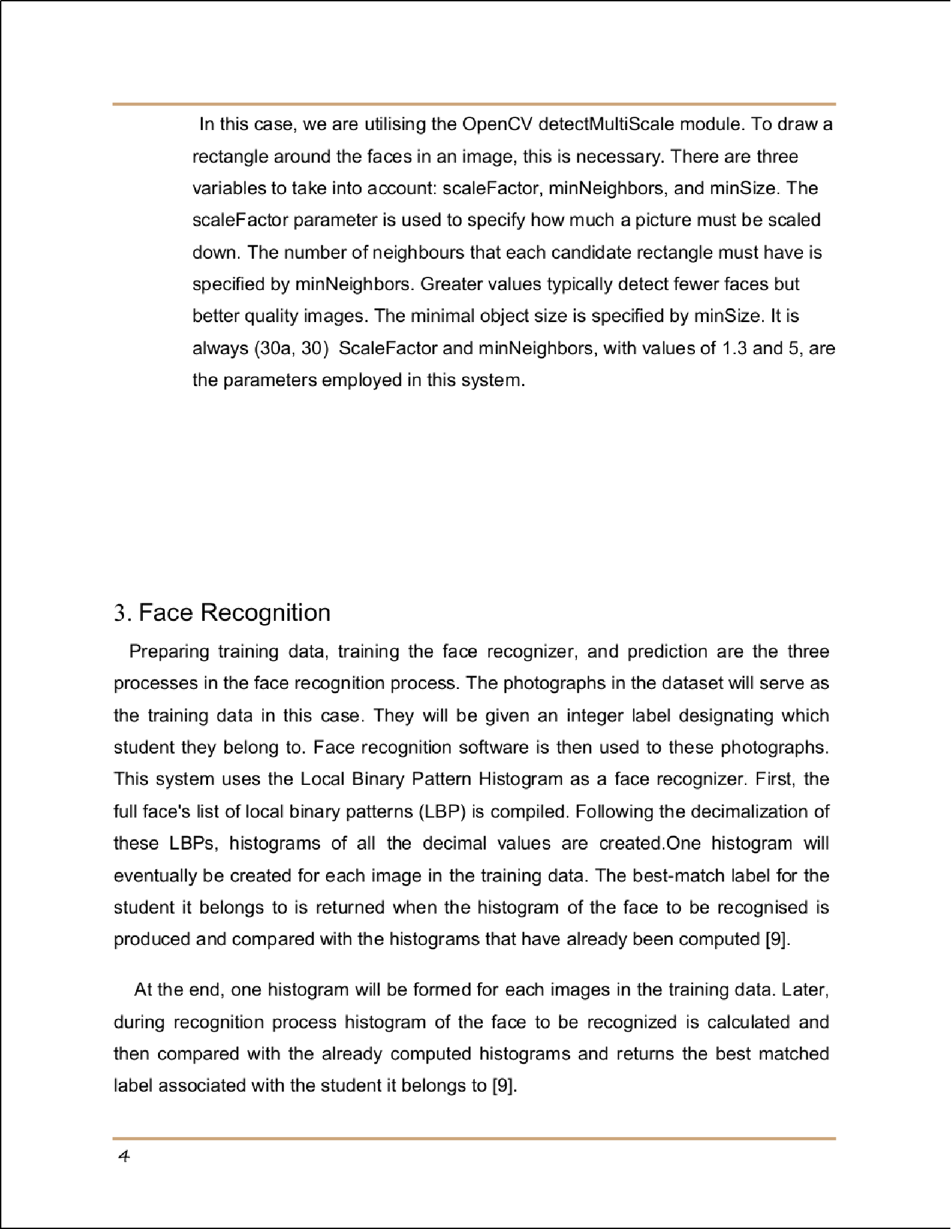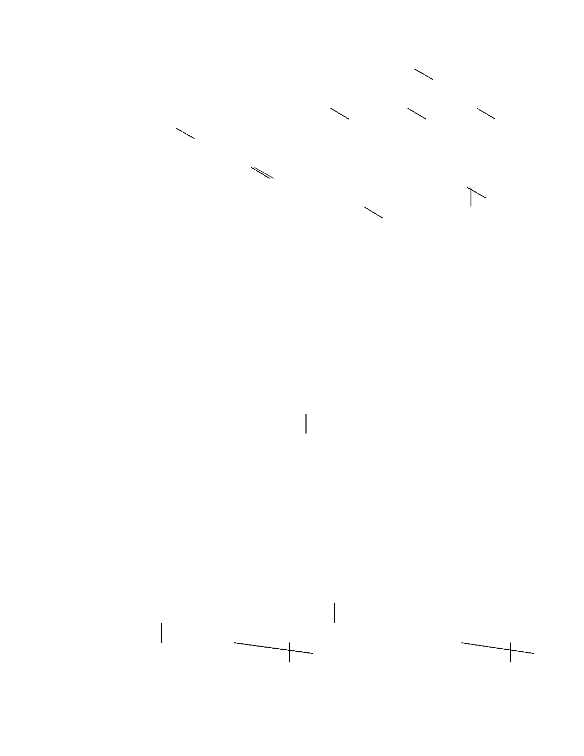

Article Error

Wrong Article

Hyph. Hyph.

Article Error

4 Article Error

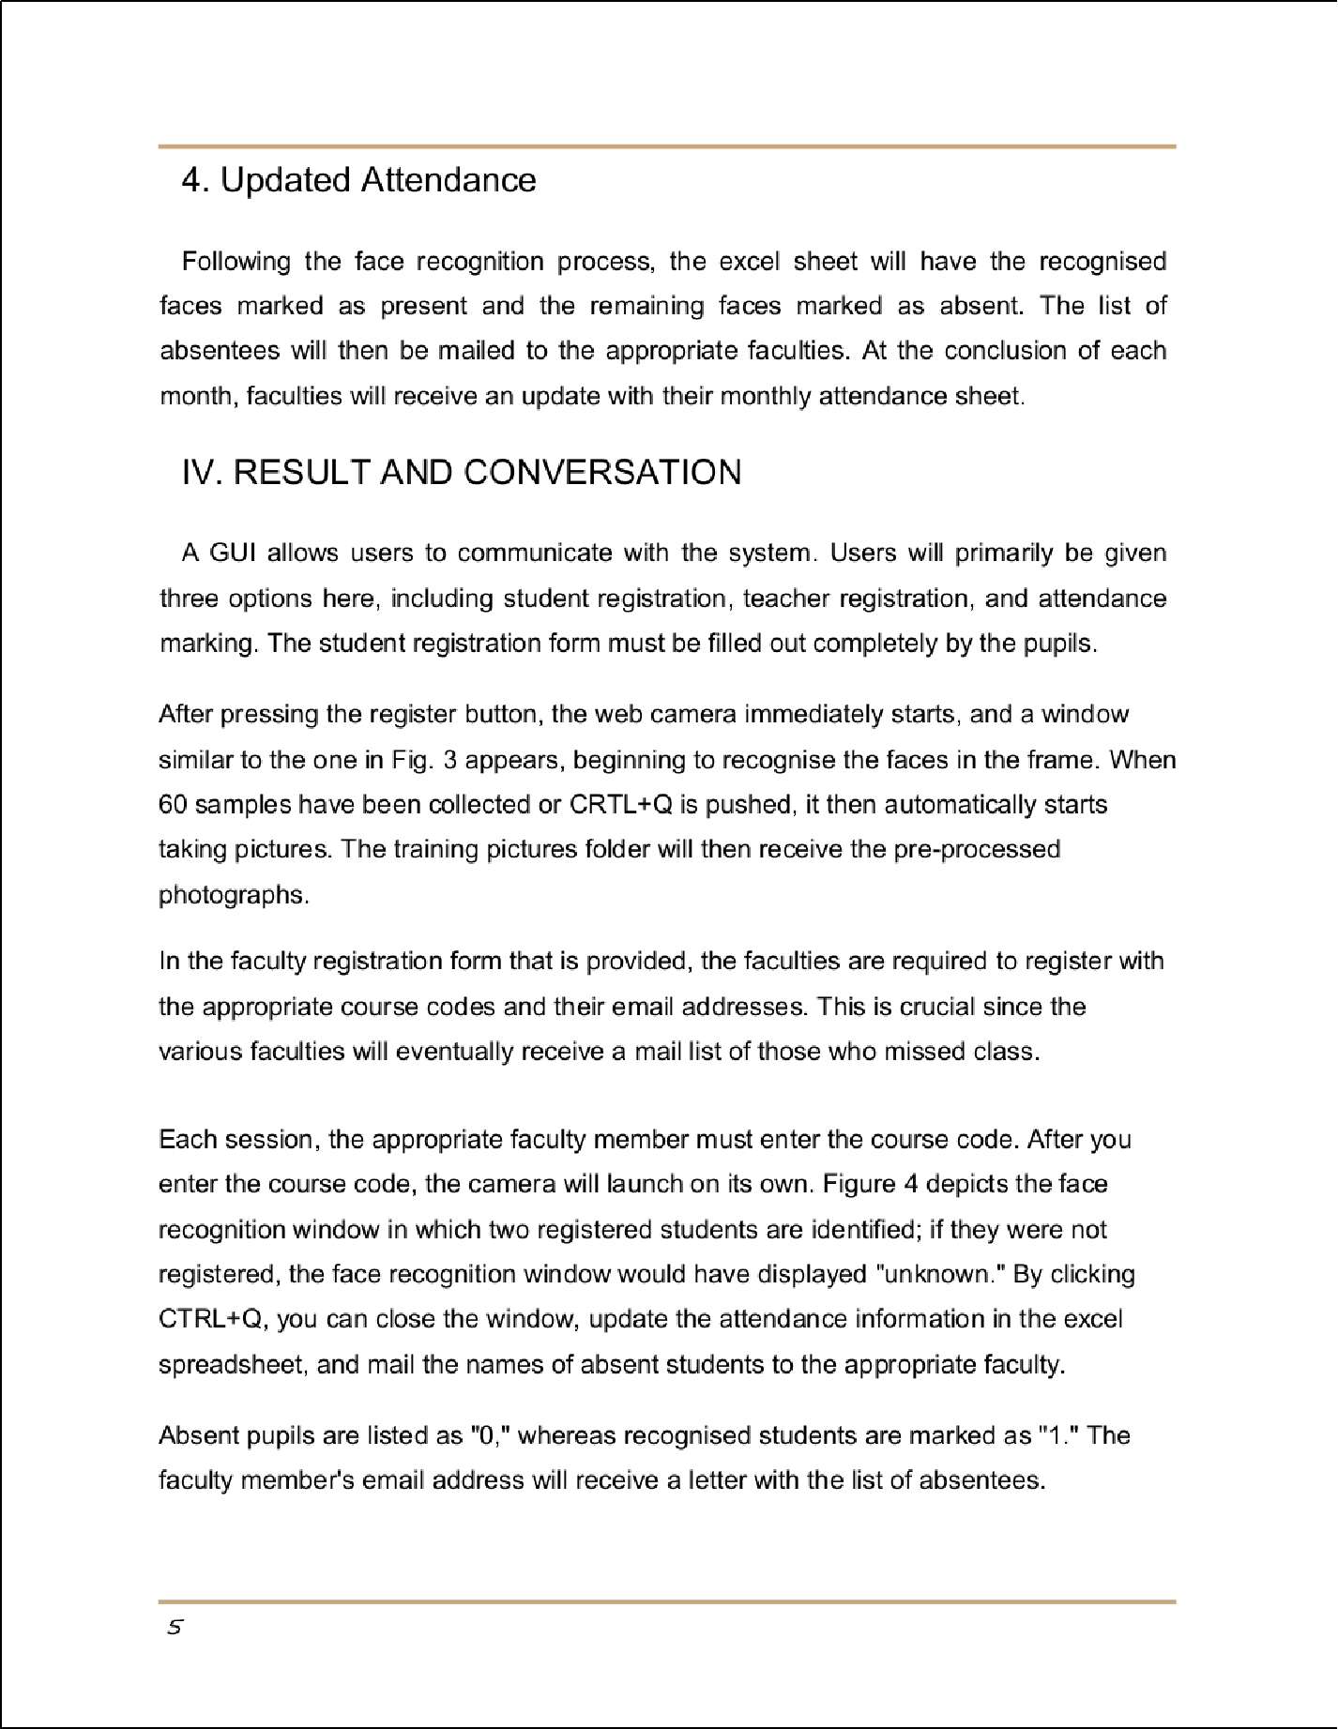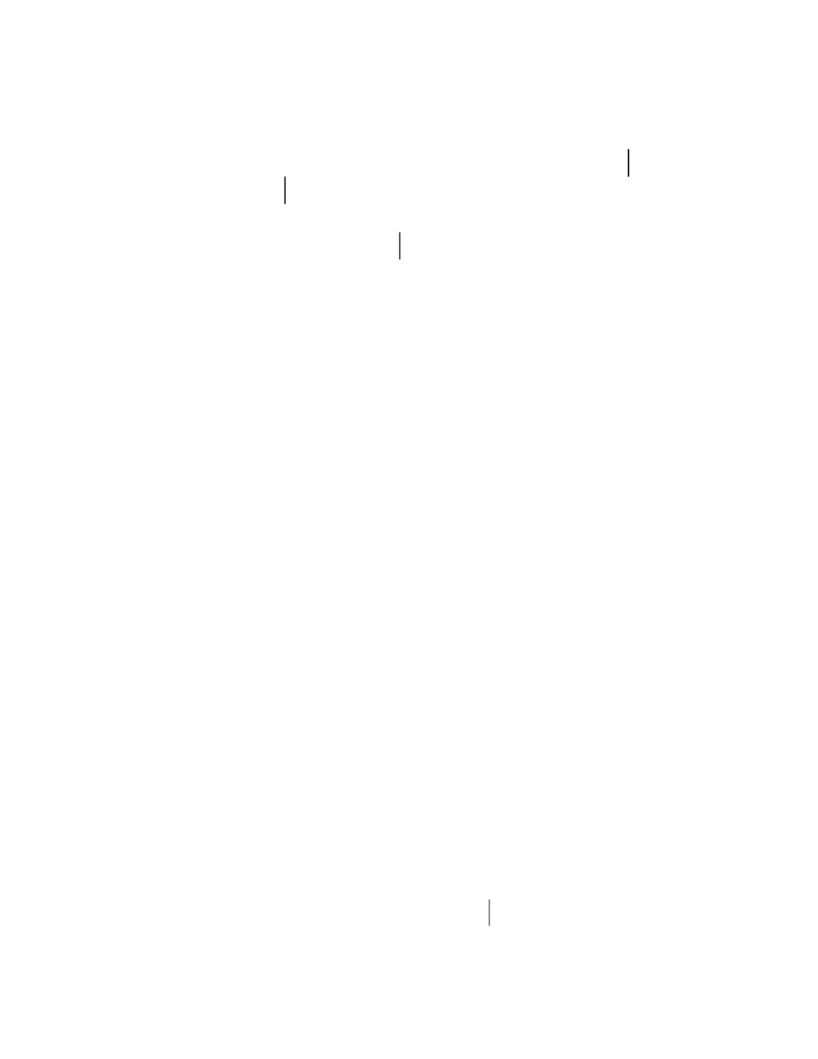

Prep.

1

1 1

1

1

1

Prep.

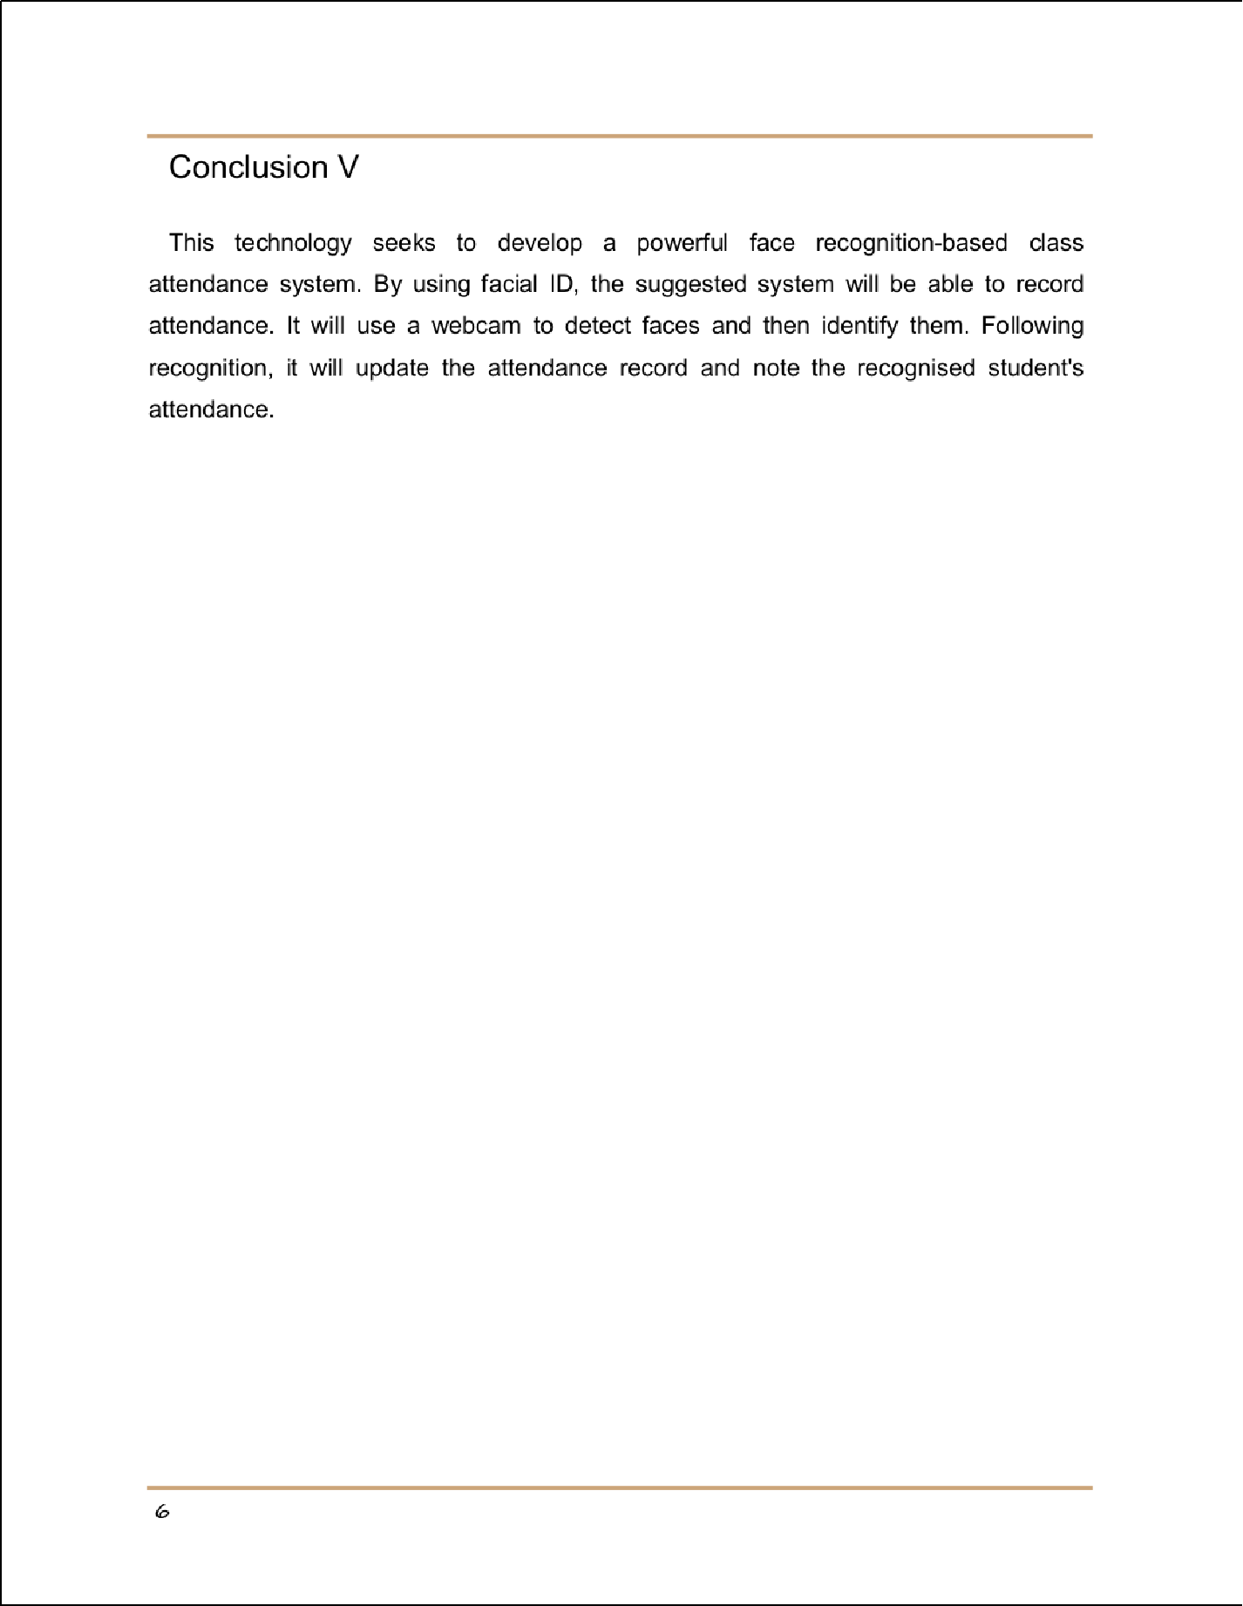

2

## Face Recognition

39

ORIGINALITY REPORT

## %

SIMILARITY INDEX

39%

INTERNET SOURCES

2%

PUBLICATIONS

## %

STUDENT PAPERS

PRIMARY SOURCES

# [www.ijert.org](http://www.ijert.org/)

1

Internet Source

# ijircce.com

2

Internet Source

# [www.irjmets.com](http://www.irjmets.com/)

3

Internet Source

# tnsroindia.org.in

4

Internet Source

# [www.researchgate.net](http://www.researchgate.net/)

5

Internet Source

# github.com

6

Internet Source

14%

11%

6%

5%

3%

1%

Exclude quotes Oﬀ Exclude bibliography On

Exclude matches Oﬀ

Face Recognition

PAGE 1





PAGE 2





PAGE 3



PAGE 4



**Wrong Article** You may have used the wrong article or pronoun. Proofread the sentence to make sure that the article or pronoun agrees with the word it describes.

**Article Error** You may need to remove this article.

**Frag.** This sentence may be a fragment or may have incorrect punctuation. Proofread the sentence to be sure that it has correct punctuation and that it has an independent clause with a complete subject and predicate.

**Article Error** You may need to remove this article.

**Article Error** You may need to use an article before this word.

**Missing ","** You may need to place a comma after this word.

**Prep.** You may be using the wrong preposition.

**Article Error** You may need to remove this article.

**Sentence Cap.** Remember to capitalize the ﬁrst word of each sentence.

**Article Error** You may need to remove this article. **Missing ","** You may need to place a comma after this word. **Article Error** You may need to remove this article.

**Prep.** You may be using the wrong preposition.

**Sp.** This word is misspelled. Use a dictionary or spellchecker when you proofread your work.



























PAGE 5

**Sp.** This word is misspelled. Use a dictionary or spellchecker when you proofread your work.

**Sp.** This word is misspelled. Use a dictionary or spellchecker when you proofread your work.

**Sp.** This word is misspelled. Use a dictionary or spellchecker when you proofread your work.

**Sp.** This word is misspelled. Use a dictionary or spellchecker when you proofread your work.

**Sp.** This word is misspelled. Use a dictionary or spellchecker when you proofread your work.

**P/V** You have used the passive voice in this sentence. Depending upon what you wish to emphasize in the sentence, you may want to revise it using the active voice.

**Sp.** This word is misspelled. Use a dictionary or spellchecker when you proofread your work.

**P/V** You have used the passive voice in this sentence. Depending upon what you wish to emphasize in the sentence, you may want to revise it using the active voice.

**Sp.** This word is misspelled. Use a dictionary or spellchecker when you proofread your work.

**Article Error** You may need to remove this article.

**Wrong Article** You may have used the wrong article or pronoun. Proofread the sentence to make sure that the article or pronoun agrees with the word it describes.

**Article Error** You may need to use an article before this word. Consider using the article

**the**.

**Hyph.** You may need to add a hyphen between these two words.

**Hyph.** You may need to add a hyphen between these two words.

**Article Error** You may need to remove this article.







PAGE 6

**Article Error** You may need to use an article before this word.

**Prep.** You may be using the wrong preposition.

**Prep.** You may be using the wrong preposition.